 | Module 7  Microscopy

Purpose | To provide you with an understanding of the appearance and various forms of acid-fast bacilli (AFB) that appear in clinical specimens
Prerequisite  Modules | Module 6
Learning Objectives | At the end of this module, you will be able to  - Describe the method for observing 100 high power fields  - Correctly use microscope objectives  - Recognize the appearance of AFB in a stained smear  - Appropriately quantify results in the Laboratory Register  - Describe the procedure for storing slides for External Quality Assessment (EQA).
Content Outline | - Required materials  - Reading the smear  - Microscope components and operation  - Appearance of AFB  - WHO/ IUATLD grading scale  - Storing smears  - Cleaning the objectives
Handout and Exercises | Exercise: Laboratory Practical session # 5: Viewing of prepared and stained smears from Laboratory Practical session # 4
Appendix | - Appendix 1- Microscope specifications  - Appendix 2 - Microscopy recording form

Module 7: Microscopy

Examination of sputum smears for acid-fast bacilli (AFB) requires a good microscope and a motivated, trained technician.

REQUIRED MATERIALS
The following materials are required to perform the microscopy of AFB smear:
- Binocular microscope with oil immersion objective
- Electric power or daylight
- Immersion oil
- Lens paper or fine tissue paper
- Lens cleaning solution
- Laboratory register
- Slide storage boxes
- Red and blue writing pens

Microscopy
A binocular microscope is recommended for reading AFB smears. It must have an oil immersion 100X objective with 8–10X magnification eyepieces, and a mechanical stage. (For complete microscope specifications, refer to Appendix 1.)

It should have a backup mirror. It is best to read in subdued lighting. If sunlight is the light source, place the microscope in front of a window but not in direct sunlight.

The microscope should be placed on a stable level bench, well away from the staining area.

MICROSCOPE COMPONENTS 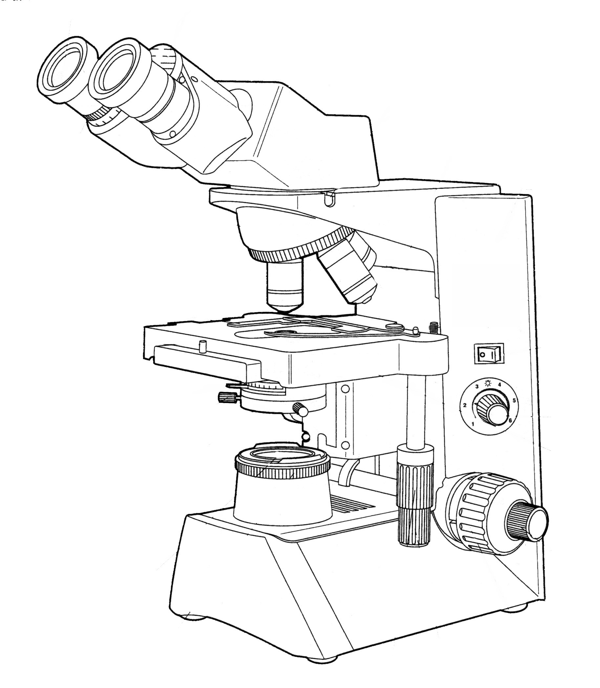

Power switch

Voltage regulator

Coarse focus knob

Fine focus knob

Stage movement X-Y axis

Eye piece

Diopter ring adjustment

Binocular tube

Nose piece

Objectives
Mechanical stage
Slide holders
Condenser diaphragm

Centering screws

Filter

Field diaphragm
Lamp

Study the components of the microscope and know how each part functions.

Microscope Part | Function
Eyepieces | Pair of lenses used to view the magnified image from the objective lens.
Diopter adjustment ring | Used to focus the image by turning it clockwise or anticlockwise to obtain a image view in the same plan for the both eyes.
Binocular tube | The part holding the eyepieces and dividing the light between them. It is used to adjust the distance between the eyes so that a single, overlapping image is obtained by both eyes.
Nose piece | The mechanical and revolving part that holds the objective lenses.
Objective lenses | These are the bunch of lenses of various magnification powers, used to view the object.
Mechanical stage | The horizontal platform to place the object for viewing.
Slide holder | Mechanical arm that is used to hold the object or slide for a smooth and uniform movement.
Condenser with diaphragm | The lens system that concentrates the light on the object to be magnified. It contains an iris diaphragm meant to reduce glare from dispersed light.
Filter | A blue-colored glass that makes the light in the visual field to appear as natural daylight.
Field diaphragm | Controls the amount of light form light source.
Lamp | Light source in the base of the microscope stand.
Coarse focus knob | Focusing knob that allows a coarse adjustment of the image.
Fine focus knob | Focusing knob that allows a fine adjustment of the image.
Power switch | Controls the power supply to microscope
Voltage regulator | Controls the amount of voltage supplied to the lamp.
Stage movement knobs | Used to move the slide in x and y direction for complete coverage of object, in our case it is the smear.

OPERATION OF THE MICROSCOPE

Learn how to correctly operate the microscope. This task is as important as performing the smear and staining procedures. It will ensure that the microscope’s lenses and other working parts are handled carefully, preventing damage to any of its important parts.

Review the details of operation in the instruction manual of each microscope.
- Plug the microscope into the electrical source and switch on the light at low intensity.
- Place a specimen slide on the stage. Be sure the slide is not placed upside down.
- Focus the specimen with the 10× objective by turning the coarse adjustment knob.
- Adjust the distance between the ocular lenses until both the right and left images become one.
- Field diaphragm- adjust Kohler illumination, if required. Refer to module 9 for details.
- Fine-focus the image with the right eye looking into the right eyepiece by turning the fine adjustment knob.
- Focus the image with the left eye looking into the left eyepiece by turning the diopter ring.
- Put one drop of immersion oil on the smear .
- Change to the 100× objective. Be sure the condenser is raised as high as possible to maintain the intensity of the light. Open the condenser iris to 70-80% of the aperture diameter. Focus the specimen slide by turning only the fine-focus adjustment knob.
- Never adjust the stage upward while looking through the eyepiece. If you do so, you will push the objective through the slide. This may damage the slide and the objective.
- Use only the 100x objective (immersion objective) for observation through immersion oil. All other objectives must be used without immersion oil and kept dry.
- To view next slide, entire procedure does not need to be repeated. Turn away the 100 X objective and take out the former slide, add a drop of immersion oil on new stained smear and insert on to stage, then turn 100 X objective.

Applying immersion oil
- Make sure that the smear is facing upwards when the slide is placed on the mechanical stage.
- Focus the smear using low power objective 10X.
- Put one drop of immersion oil on the stained smear, letting it fall freely onto the slide.
- Never allow the oil applicator to touch the slide. Touching the slide with the applicator could lead to contamination of the oil with AFB and could transfer AFB to a negative slide.

READING THE SMEAR

- Carefully rotate the 100x objective over the smear and focus it.
- Systematically examine the smear under the 100X objective.
- Scan smears by moving across the smear in a horizontal direction.
- Stop and observe each field before moving onto the next field.
- Read at least 100 high power fields before reporting a negative result. (Note: Fewer than 100 fields may be read if the slide is found positive for AFB.)
- Usually examining 100 fields takes about 5 minutes.

Appearance of AFB in the smear

AFB stain red or pink against a blue background with the Ziehl-Neelsen staining method. They are usually thin and rod-shaped, but occasionally may appear as coccoid (beaded), filamentous (thread-like), or clumped (in group) forms.

WHO/IUATLD GRADING SCALE

Reporting scale
Follow the scale when reporting smears:
- If no AFB are seen in at least 100 fields, report as negative for AFB.
- If 1–9 AFB are seen in 100 fields, report actual number of AFB seen.
- If 10–99 AFB are seen in 100 fields, report as (1+).
- If 1–10 AFB/field in at least 50 fields report as (2+).
- If more than 10 AFB/field in at least 20 fields, report as (3+).

Reporting scale | AFB seen
Negative | No AFB seen in at least 100 fields
Actual number | 1-9 AFB per 100 fields
(1+) | 10-99 AFB per 100 fields
(2+) | 1-10 AFB per field in at least 50 fields
(3+) | More than 10 AFB per field in at least 20 fields

Recording results
- Record results in the laboratory register immediately after reading smears.
- Use a red pen to recording POSITIVE results in the laboratory register.

Return the completed Request for Sputum Examination form to the requesting doctor or clinic.

The laboratory register is not only an important record of laboratory results but also helps indicate laboratory performance.
Such performance indicators include:
- Positivity rates among suspects and follow up patients
- Consistency with case series
- Case yield of first smears
- Ability to detect low positive case smears

STORING SMEARS
- Store ALL slides in slide boxes in the order they were recorded in the laboratory register. This will allow easy sampling of slides for external quality assessment using blinded slide rechecking.
- Ensure that three slide spaces are left for each new diagnostic case.
- Remove oil from smears either by placing the slide face down on toilet tissue or wrapping it in the tissue and leaving it this way overnight. Gravity helps remove most of the oil when the slide is kept straight up in the slide rack overnight.
- Xylene is not necessary to remove oil at the peripheral level. Xylene should never be used to clean the microscope or dilute immersion oil.

CLEANING THE OBJECTIVES

- After reading the smears, gently wipe the objective lens with lens paper or fine tissue paper.
- NEVER use petroleum, benzene, acetone, or xylene to clean objective lenses.
- After cleaning, cover the microscope with a vinyl or cotton cloth cover and store it in a place free from moisture and dust.

Key messages   | - Use the WHO/IUATLD grading scale for the smears.  - Systematically scan the slide by moving across the smear in a horizontal direction.  - Examine each field before moving onto the next field.  - Read at least 100 high power fields before reporting a negative result.  - Store all examined smears in the order they appear in the laboratory register.

 | Module Review: Module 7
Find out how much you have learned by answering these questions.
How many AFBs are required for a 1+, 2+, and 3+ smear?
_____________________________________________________________________________

How many fields need to be examined when reading a smear for AFB? _______________________________________________________________________________________________________________________________________________________________________________________________________

Which smears must be stored after examination?
______________________________________________________________________________________________________________________________________________________________________________________________________
When and how are microscope objectives cleaned?
______________________________________________________________________________________________________________________________________________________________________________________________________

Appendix 1
Microscope specifications

- Microscope must be completely UL*, CSA* and CE* tested, listed, and approved to insure fire and/or shock safety. Only UL listed components or line cords are not acceptable.
- Must have10x/18mm eyepieces.
- Must have auto compensating Siedentopf style binocular with diopter scale for interpupillary distance (must have visible diopter scales).
- Must have 4-position reversed nosepiece of metal construction with internal ball bearing stops. External clip system not acceptable.
- Must have 4x HI-Plan, 10x HI-plan , 40x HI-plan, and 100x oil HI-plan parfocal and parcentered infinity corrected objectives.
- Mechanical stage must be of built-in design with metal rack and pinion X-Y drives. No polymer belts, metal cables, timing belt systems or non-metallic components are acceptable in the drive mechanism. Coaxial controls must be low mounted for ease of use.
- Pre-aligned Abbe condenser with graduated iris diaphragm wheel with markings to show where iris aperture should be set for each objective magnification.
- Focus drive must be a self-tensioning, three ball design of all metal construction. Fine focus must have graduations of 100 divisions and 3 microns per division. Focusing knobs on both sides must have these markings.
- All gears throughout the microscope: mechanical stage, focus, condenser rack and pinion must be made of metal, brass, stainless steel or aluminum – no plastic components.
- Illumination system must be designed for 12v/35w tungsten halogen 2,000 hour average life bulb.
- Microscope must have hinged lamp door that is angled to help prevent breakage. Sliding “drawer” type bulb covers not acceptable for safety reasons.
- Must have blue filter fixed into its mount, not loose. In Koehler kits, lollipop filters have “locking slots” to prevent them from falling out when tilted.
- Microscope base temperature must not exceed 37 degrees centigrade using a 12v/20w halogen lamp at full voltage for 6 hours.
- Power supply must be voltage sensing 85-265 volts with surge suppression and soft start lamp control.
- Lamp intensity must be conveniently located in stand armrest and controlled via an illuminated rotating wheel.
- Stage finger assembly is to be slide friendly that does not damage or break slides.
- Microscope must have ergonomic design.

*UL: Underwriters Laboratories Inc.
*CSA: Canadian Standards Association
*CE: Conformance European

Slide number | Smear appearance | Smear Results
Slide number | Smear appearance | Negative | Characteristics of AFB
Slide number | Smear appearance |  | Colour | Appearance | Size | Arrangement
1
2
3
4
5
6
7
8
9
10
Appendix 2
Microscopy
Recording Form
(For Laboratory Practical Session# 5)

Participant's Name_______________________ Date____________________

Workshop Place___________________

